**Project Report On**

**“Fashion Store”**

**(Distributed and Pervasive Computing – CS 556)**

**Developed and Presented by:**

**Sneha Venkatesh**

**Samanvitha Ramayanam**

# Introduction

The computer technology has brought vast changes in the lives of man. The computers have had tremendous influence on the outlook of the lives lead by man. The computers themselves have undergone vast changes since the time they were invented. In the early stages of computing we had “mainframe computers “which were used by many people. Then there came a stage when computer hardware became cheap and hence “personal computers” started entering the lives of people. Here people started having computers for themselves. Desktops and laptops became popular. Now we are living in the hi-tech age where technology forms the background in our lives.

Ubiquitous computing refers to the calm technology. Here technology becomes invisible. Ubiquitous computing refers to how computers are available everywhere and how they are connected. It is this computing which is making man’s life so comfortable. Ubiquitous computing is so prevalent in our life that we have stopped noticing that it uses some technology. The way billboards change, traffic signals change, the scanning of items on cash desk etc all use technologies which we take for granted. Ubiquitous computing is so prevalent in our everyday life that it is difficult to even make note of it. It is now a part of our daily life and is expected to be present. The technologies which are already prevalent can be used to enhance our lives and make it more comfortable.

When we started thinking of developing an application that will be useful to each one of us in our daily lives, we thought why not make this application in such a way that combines the concepts of communication, computation and intelligence. Then we came up with a new idea called “fashion store” which is an application that helps all of us in an important and tough task for most of us which is shopping for our clothes or accessories. This application is really helpful for those of us who are not willing to spend much time for shopping or also for those who are too tired to check out all the items that are available in the store but at the same time would like to buy fashionable clothes.

Usually when a person enters a store to buy clothes, he would have to pass through every aisle and look for the clothes that would suit him. This is a tough and tedious task as he needs to go through several clothes that are available in several stores before he finds the clothes that he would like to purchase. Even after going through this tedious task of finding the clothes that he may like, most of the times the cost of the clothes may not suit the budget of that person. In such a case the person would be wasting a whole lot of time without being able to get the clothes that he needs. Having an application which will help the customer to identify the clothes that he may be interested in as soon as he enters the store without having him go through all the clothes would be such a relief for the person who is out for shopping. And wouldn’t it be all the more great if the clothes that the application can suggest suits the person’s budget as well. Well that is what the Fashion Store application can do.

# Fashion Store Application

The Fashion Store Application can be of great help to anybody who wants to go out for shopping.

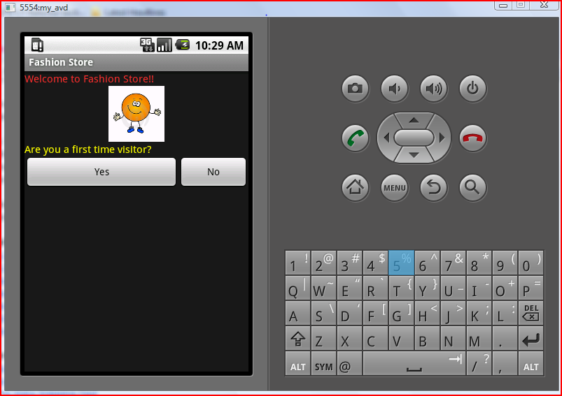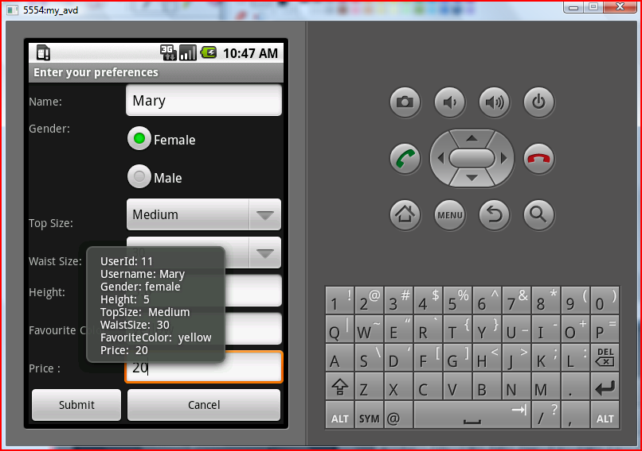

If the user is the first time visitor, then the application takes user’s personal details such as his age, height, size, and other details such as his favorite color and the price which he is willing to spend for the clothes that he wants to purchase. All these information provided by the user will be stored into the database, so that it can be used later if the user enters the same shop again. Also an ID will be provided to the user which is required later for the user to view the clothes as shown in the above screen shots.

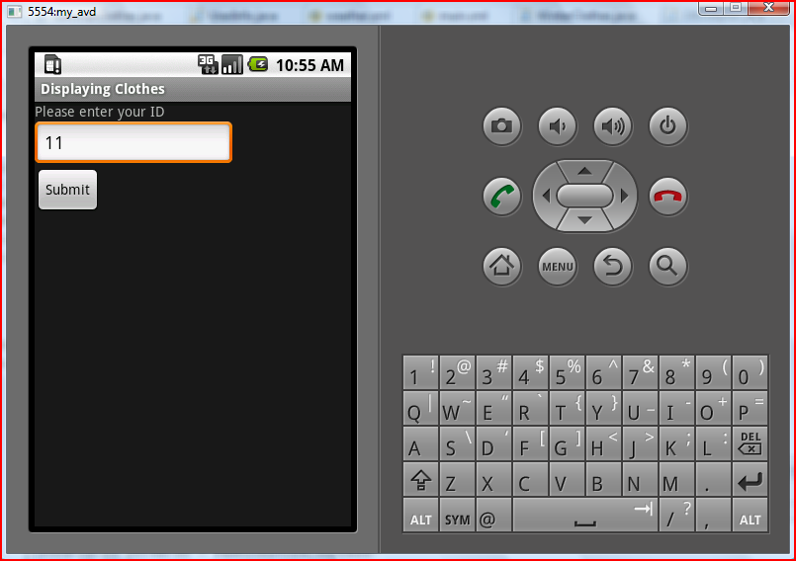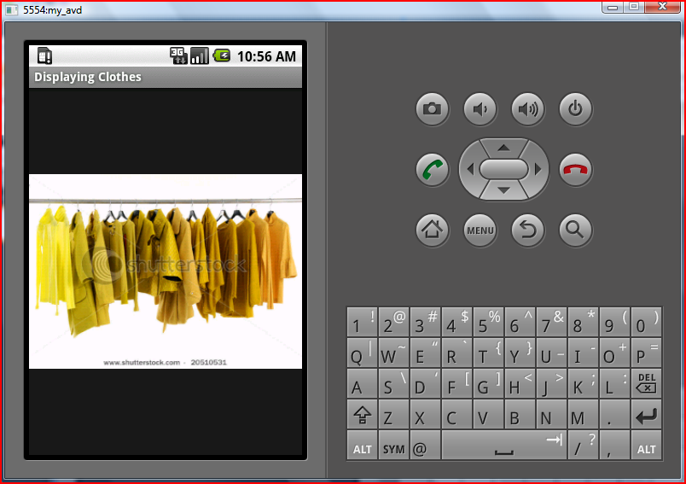

If the user is not a new customer then the application will just asks for the ID of the user which will be provided to him when he first visited the shop. If the user enters the ID, then the system will access the database of the store and depending on the requirements which the user has entered, it selects the clothes that the user may be interested in and presents it to the user.

The customer is presented with the pictures of all the clothes that he may be interested in. Now he can look at all the choices given to him and directly go to the clothes that he would like to buy or may want to move out of the store and try elsewhere if he is not satisfied with the choices that he is offered at that store. The best thing about this application is that the clothes which are presented to the user are sorted not only to ensure that the size and the favorite color of the user matches, but also the budget of the user is taken into consideration before the choices are displayed.

Key points about the Fashion Store Application are:

1. The user is displayed with a variety of clothes that would suit his requirements in terms of size as well as color.
2. The pictures of the clothes are displayed which gives the user an idea about the clothes and will enable the user to see and select the clothes there itself before actually going down to that particular aisle in which the clothes are stacked in.

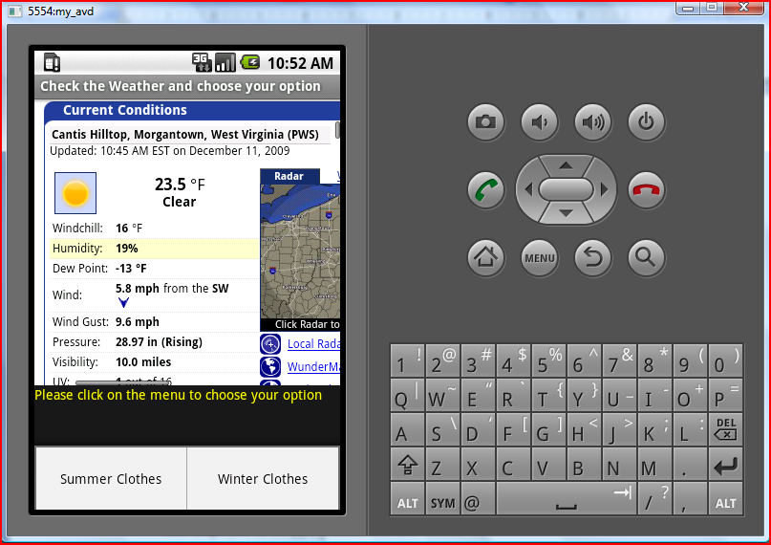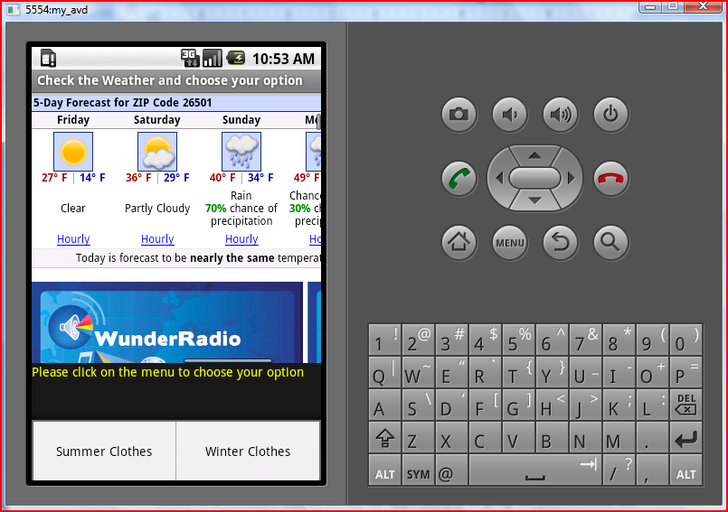

1. The application also provides the user a chance to check out the weather conditions before he shops for clothes as shown in the above screen shots. This is a very useful feature because the user can actually check for the weather condition and see how it would be like for the next couple of days and then may look out for clothes which will suit the climate.
2. With the feature of letting the user check out the weather conditions before he buys clothes or accessories that he needs, the application is helping the user to select the right things he needs to purchase.
3. The application also makes sure that the price of the choices which are displayed to the user suit the price that the customer is willing to spend on the clothes.
4. The application thus makes sure that the time that the customer spends on shopping for the clothes that he wants to purchase is reduced greatly by showing him all the clothes that he may be interested in, right at the entrance of the store without having him to go around the whole store to check for the clothes.
5. Thus the application is great to use as it saves a lot of time, energy and at the same time helps you in shopping faster and also effectively.

# Enhancements

The Fashion Store Application that we have developed is great to use with the kind of service that it provides. Given a chance to develop it further, we would be able to add more features and enhance the application even more so that it would provide many more benefits to its users. Some of the key points that we would like to add to our application which would enhance it further are:

1. When the application displays the pictures of the clothes, it can suggest the user about the location of the clothes by providing the section name or number of where the clothes are placed.
2. The application that we have built right now is able to help the user only for the purchase of the clothes from one single store which we have named the fashion store. However we can modify this and ensure that the application can access the databases of all the stores and help its user to choose clothes from any store that he enters into.
3. The store which the user has entered into can be identified by the application itself when it is connected to a GPS and can access information from it. This would make it easier for the user as he need not enter the name of the store which he has entered, it would be directly identified by the application.
4. We can also add a feature into the application which would help the users connect to their friends and show them the choice of the clothes that they have before them and take the opinion of their friends before purchasing the clothes.
5. We can also modify the application in such a way that it would keep a track of all the choices that the user was presented with in their previous visit to the store and can give notifications to the user depending on the new arrivals and the offers that are available in the store.
6. A further step of enhancing the application is to modify the application giving it the ability to take a picture of the user or choose a picture already stored and show the user how they would look in those clothes giving them a chance to look at how the clothes would suit them without having to try all of them and check how they look.

All the above enhancements to the application would make the Fashion Store Application much more interesting and useful for the users.